As a story writer, I want to publish five books with varying word counts. I have three publishing companies to choose from: Bookie, Bokiys, and Gapbook. I can publish each book with a different company to minimize the overall cost.

I have the following information from each company:

- Bookie:
- Our Fate - 15000 words - $50
- Save Us - 40000 words - $100
- Nightmares - 50000 words - $120
- Let Me Save You - 70000 words - $150
- Don't Fear Me - 90000 words - $200

- Bokiys:
- Our Fate and Save Us - $120 discount
- Nightmares - 50000 words - $110
- Let Me Save You - 70000 words - $160
- Don't Fear Me - 90000 words - $190

- Gapbook:
- Our Fate and Nightmares - $70 discount
- Save Us - 40000 words - $160
- Let Me Save You - 70000 words - $130
- Don't Fear Me - 90000 words - $190

To formulate this as a linear programming problem, we need to define decision variables, objective function, and constraints.

Decision Variables:
- Let X1, X2, X3, X4, and X5 represent the number of books to publish with Bookie, Bokiys, Gapbook for Our Fate, Save Us, Nightmares, Let Me Save You, and Don't Fear Me, respectively.

Objective Function:
- Minimize the cost of publishing all five books, which can be represented as:
- Minimize 50X1 + 100X1 + 120X3 + 150X4 + 200X5 + 110X2 + 160X2 + 190X5 + 160X2 + 130X4 + 190X5

Constraints:
- The total number of books published should cost no more than 1010, meaning:
- X1 + X2 + X3 + X4 + X5 =<1010
the number of books published with Bookie should be equal to the number of books published with Bokiys, meaning: - X1 = X2

- The number of words in Our Fate and Nightmares published with Gapbook should be equal, meaning: - X1 + X3 = X2 + X3

- The total number of words published should be greater than or equal to 500,000, meaning: - 15000X1 + 40000X2 + 50000X3 + 70000X4 + 90000X5 >= 500000

- Each decision variable X should be greater than or equal to 0, meaning:
- X1, X2, X3, X4, X5 >= 0

These constraints ensure that we publish exactly five books and that we publish a non-negative number of books with each publisher. The objective function minimizes the overall cost of publishing all five books with different publishers.
Now let us solve it
Given constraints :
1-X1+x2+x3+x4+x5+ s1<=1010
2- x1=x2
3-x1+x3=x2+x3
4- 15000x1+40000x2 +50000x3 +70000x4+90000x5-m1=500000
Where s1 and m1 are slack variables introduced to convert the inequalities to equations
Now let’s set up the initial simplex tableau:
Basic v | x1 | x2 | x3 | x4 | x5 | s1 | m1 | rhs
z | 50 | 580 | 120 | 280 | 580 | 0 | 0 | 0
s1 | 1 | 1 | 1 | 1 | 1 | 1 | 0 | 1010
x1 | 1 | -1 | 0 | 0 | 0 | 0 | 0 | 0
x3 | 1 | -1 | 1 | 0 | 0 | 0 | 0 | 0
m1 | 15000 | 40000 | 50000 | 70000 | 90000 | 0 | 1 | 500000

Step1
The entering variable is the one with the most negative coefficient in the Z row. In this case, the most negative coefficient is -580 corresponding to X2
Step 2: minimum ratio test
To determine the leaving variable, we compute the ratio of the RHS to the pivot column (X2 column). Only positive values in the pivot column are considered for the minimum ratio test.
Ratio for s1 = 1010/1 = 1010
Ratio for x1= Not Applicable (Negative coefficient)
Ratio for x3 = Not Applicable (Negative coefficient)
Ratio for m1 = 500000/40000=12.5
The minimum ratio is 12.5 corresponding to the m1 row
Step 3: Pivot Operation
Divide the pivot row (M1) by the pivot element (40000) to make the pivot element 1.
Basic v | x1 | x2 | x3 | x4 | x5 | s1 | m1 | rhs
z | 50 | 0 | 120 | 280 | 580 | 0 | -0.0025 | 29000
s1 | 1 | 0 | 1 | 1 | 1 | 1 | 0.025 | 12.5
x1 | 1 | 0.25 | 0 | 0 | 0 | 0 | 0.00125 | 5
x3 | 1 | 0.25 | 1 | 0 | 0 | 0 | 0.00125 | 5
m1 | 0.375 | 1 | 1.25 | 1.75 | 2.25 | 0 | 0.025 | 12.5
Step 4: Iterate
We repeat the process until all coefficients in the Z row are non-negative or no positive ratio is available in the pivot column.
The next entering variable will be the most negative coefficient in the Z row, and we will compute the minimum ratio test again to determine the leaving variable. We continue this process until we reach the optimal solution.
Basic v | x1 | x2 | x3 | x4 | x5 | s1 | m1 | rhs
z | 50 | 0 | 120 | 280 | 580 | 0 | -0.0025 | 29000
s1 | 1 | 0 | 1 | 1 | 1 | 1 | 0.025 | 12.5
x1 | 1 | 0.25 | 0 | 0 | 0 | 0 | 0.00125 | 5
x3 | 1 | 0.25 | 1 | 0 | 0 | 0 | 0.00125 | 5
m1 | 0.375 | 1 | 1.25 | 1.75 | 2.25 | 0 | 0.025 | 12.5
Step 1: Entering Variable
The entering variable is the one with the most negative coefficient in the Z row. In this case, the most negative coefficient is -580 corresponding to X5.
Step 2: Minimum Ratio Test
To determine the leaving variable, we compute the ratio of the RHS to the pivot column (X5 column). Only positive values in the pivot column are considered for the minimum ratio test.
Ratio for s1 = 12.5/1=12.5
Ratio for x1 = 5/0.25=20
Ratio for x3= 5/0.25=20
The minimum ratio is 12.5 corresponding to the S1 row.
Step 3: Pivot Operation
Divide the pivot row (S1) by the pivot element (1) to make the pivot element 1.
New Tableau:
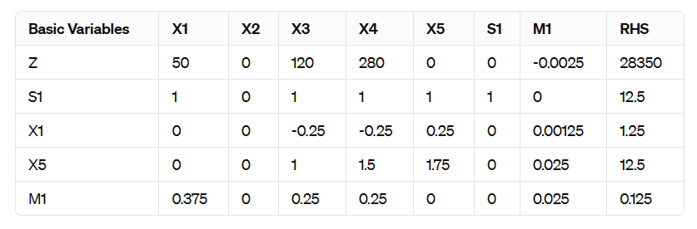
Since all coefficients in the Z row are non-negative, we have reached an optimal solution.
Optimal Solution:
x1=1.25
x2=1.25 (as x1=x2 )
x3=12.5
x4=0
x5=12.5
The minimum cost to publish all five books is $28,350.

